Lines and angles VII

- Find the complement of each of the following angles:-
(i) 47° (ii) 73º (iii) 35°
- Find the supplement of each of the following angles:-
(i) 80° (ii) 105° (iii) 123°
- 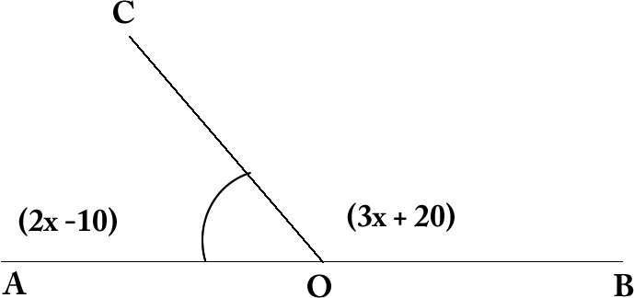 AOB is a straight line and ray OC stands on it. AOC = 2x -10 and BOC = 3x +20. Find each angle ?
- 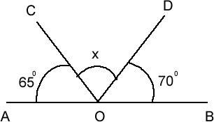 If AOB is a straight line and rays OC and OD stands on it. If AOC=65°, BOD=70°. Find COD ?
- 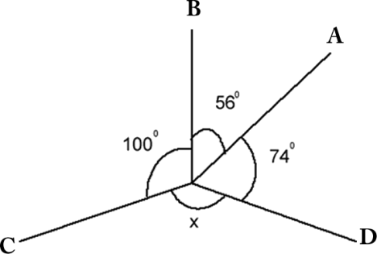 In the given figure rays OA, OB, OC and OD are such that AOB = 56°, BOC=100°, COD=x°, DOA=74°. Find the value of x?
- 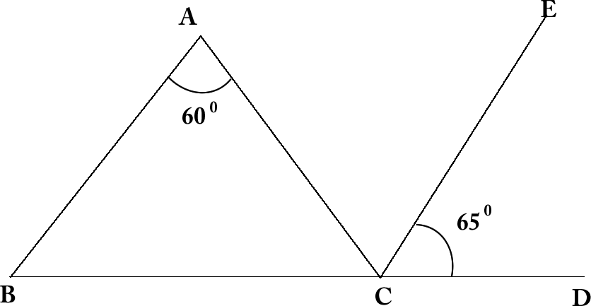 A = 60⁰ CE || BA and ECD = 65⁰ Find ECD ?
- 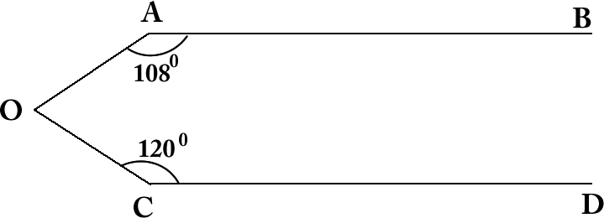 AB || CD BAO = 108⁰ and OCD = 120⁰. Find AOC.
- 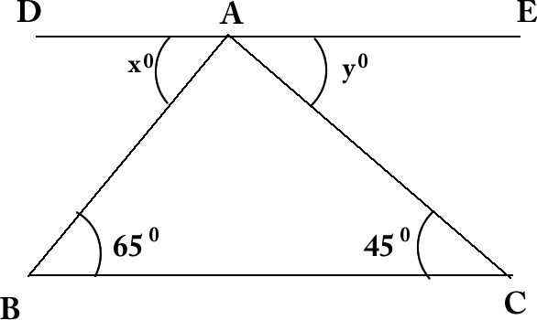 B = 65° and C = 45° in ABC and DAE || BC if DAB = x⁰ and AEC = y⁰. Find the value of x and y.
- 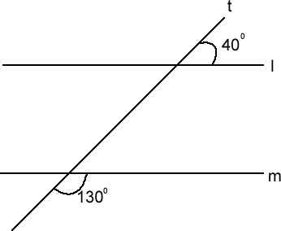 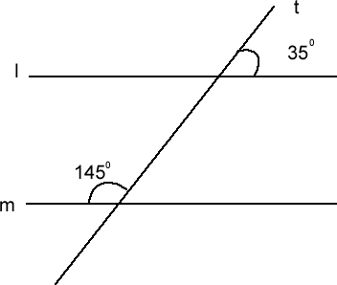 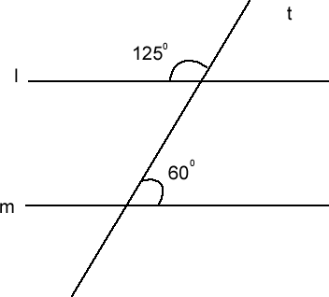 Find l || m yes or no give reason?

