Circles & Probability

- AB and CD are two parallel chords of a circle which are on opposite sides of the centre such that AB = 10cm, CD=24cm and distance between AB and CD is 17cm. Find radius of the circle.
- Two circles where centers are O and O' intersect at P Through P' a line parallel to co', intersecting the circles at C and D is drawn, Prove that CD = 200'
- Show that if two chords of a circle bisect each other, they must be diameters of the circle.
- In a circle of radius 5cm, AB and AC are two equal chords such that AB = AC = 6cm. Find the length of the chord BC.
- In the given figure AB is a chord of a circle with centre O and AB is produced to C such that BC= OB. Also CO is joined and produced to meet the circle in D. If ACD = y⁰ and AOD = x° . Prove that x = 3y.
- An equilateral triangle of side 9 cm is inscribed in a circle. Find the radius of the circle.
- Find x in each of the following figures:-
(i)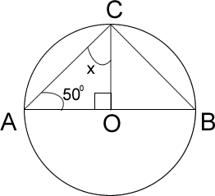 (ii) 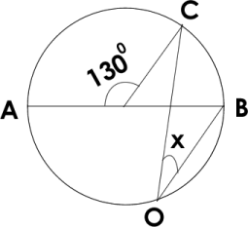 (iii) 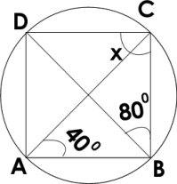(iv) 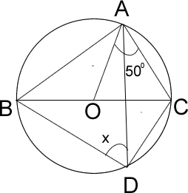
- In the given figure , AB is a diameter of the circle with centre O, AC and BO produced meet at E and COD= 40⁰ calculate CED.
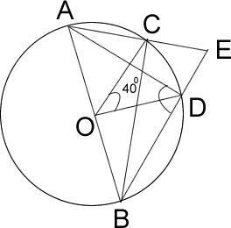 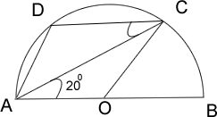
- In the given figure, AB is a diameter of a circle with centre O and CD || BA. If BAC = 20⁰ find (i) BOC (ii) COD (iii) CAD & AD
- The bisectors of opposite angles P and R of a cyclic quadrilateral PQRS intersect the corresponding circle at A and B respectively. Prove AN is a diameter of circle.

