Maths IX Circles

- Two chords AB and AC of a circle are equal. Prove that - that centre of the circle lies on the angle bisector of BAC.
- In a circle of radius 5 cm, AB and AC are two chords such that AB = AC = 6cm. Find the length of the chard BC.
- Two circles of radii 5cm and 3cm intersect at two points and the distance between their centers is 4cm. Find the length of the common chord.
- OD is perpendicular drawn from the centre a chord AB. If BC is a diameter show that AC = 2DO.
- In a circle with centre O chord AB and CD intersect insic of the circumference at E. Prove that AOC + BOD = 2 AEC.
- The quadrilateral formed by angle bisectors of a cyclic quadrilateral is also cyclic.
- Prove that diameter subtends right angle on the circle.
- 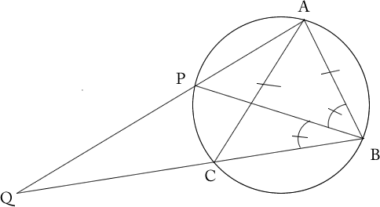 The bisector of B of an isosceles triangle with AB = AC meets the circumcircle of ABC at P. If AP and BC Produced meet at Q prove that CQ = CA.
- 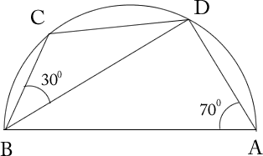 Find ABD and BDC.
- 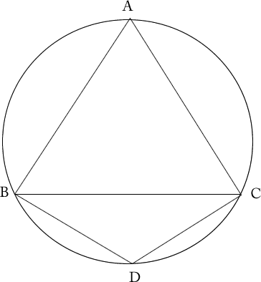 BD = DC, DBC = 25⁰ find BAC.
- 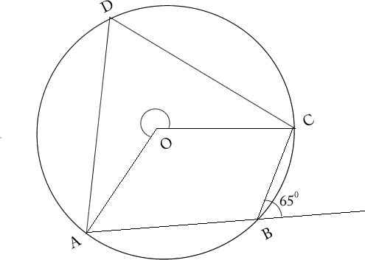 Find x.
- 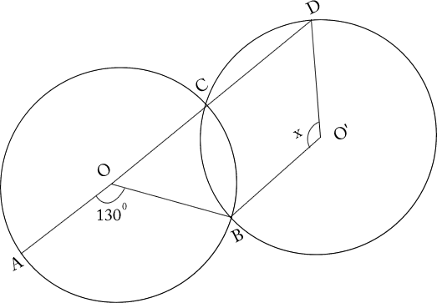 Find x.

