Quadrilateral IX

- Show that if the diagonals of a quadrilateral are equal and bisects each other at right angle, then it is a square?
- In a triangle, ABC median AD is produced to x such that AD=DX Prove that AbXC is a parallelogram.
- ABC is an isosceles triangle in which AB = AC. AD bisect exterior angle APC and CD || AB. Show that
(i) DAC = BCA (ii) ABCD is parallelogram.
- Two parallel lines l and m are intersected by a transversal. Show that the quadrilateral formed by the bisectors of exterior angles is a rectangle.
- ABCD is a trapezium in which AB || CD and AP=BC, Show that
(i) LA = LB (ii) Diagonal AC = diagonal BD.
- 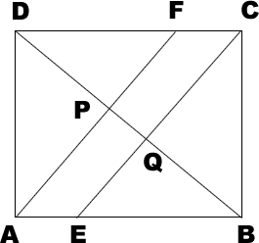In a parallelogram ABCD. E and F are the midpoint of sides AB and CD respectively Show that the line segment AF and EC trisect the diagonal BD.
- 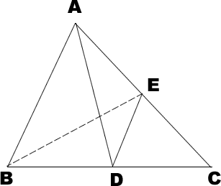 AD is the median of ABC and DE || AB Prove that BE is the media.
- ABCD is a rectangle in which diagonal AC bisect LA as well as LC show that
( i) ABCD is a square (ii) AD bisect B and D.
- 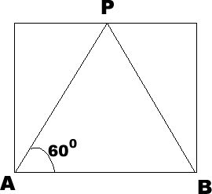 AP bisect A and PB bisect B - Prove that AD = DP and DC =2AD. Consider ABCD is a parallelogram.
- Show that the bisectors of angles of parallelogram form a rectangle.

