Electricity X

- Calculate the member of electrons constituting 4 coulomb of charge?
- On what factors does the resistance of a conductor depend?
- Why are coils of electric Toasters and electric irons made of an alloy rather than a pure metal?
- A piece of wire of resistance R is cut into five equal parts; these parts are then connected in parallel. If due equivalent resistance of this combination is R' Find the ratio of R'/ R.
- Two conducting wire of the same material and of equal lengths and equal diameters are first connected in series and then in parallel in an electric circuit. The ratio of heat produced in parallel and series.
- A copper wire has a diameter of 0.5 mm and a resistivity of 1.6x${10}^{-6}$ Ohm. How much of this wire would be required to make a 10 ohm. How much does the resistance change if the diameter is doubled?
- A wire of resistivity P is stretched to double its length? What is its new resistivity?
- What sets the electrons into motion in an electric circuit?
- Four resistances, each of 10Ω are connected to form a square, find the equivalent resistance between two points of any one side. 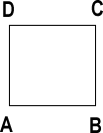
- A wire of resistance 1 Ω is divided into two halves and both halves are connected in parallel. Find the new resistance?
- 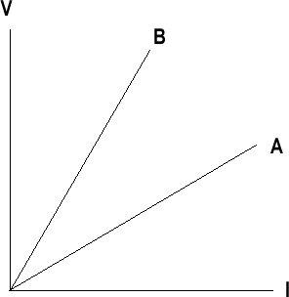 The VI graphs of parallel and series combinations of A two metallic resistors, which graph represents the parallel combination?
- The following apparatus is available in a laboratory
Battery - 0 to 6v adjustable
Resistor - 3 Ω and 6 Ω
Ammeters: A1 of range 0-3 A, least count 0.1A
A2 of range 0-10A least count 0.05 A
Voltmeter: V1 of range 0 – 10V least count 0.5A
V2 of range 0 – 5V least count 0.1A
Which is the best combination of voltmeter and ammeter for finding the equivalent resistance or resistor in series?

